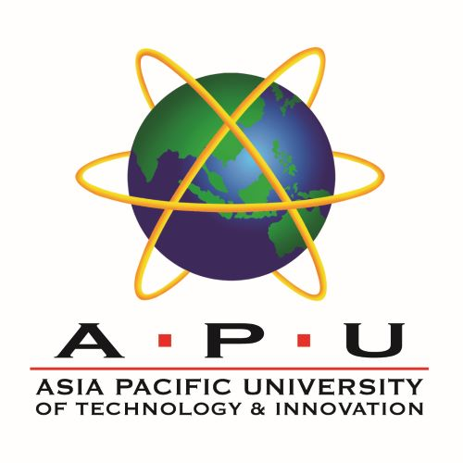 | 

INDUSTRY VISIT REPORT, NAFEMS REPORT
AND E-PORTFOLIO

TEGAR WICAKSONO
TP066268

EE014-3-3-EIS

BACHELOR OF MECHATRONIC ENGINEERING WITH HONOURS

MODULE LECTURER
IR. TS. SUBHASHINI GOPAL KRISHNAN

A report submitted in partial fulfilment of the requirements
of the module Engineers in Society (EE014-3-3-EIS)
BEng (Hons) in Mechatronic Engineering

ASIA PACIFIC UNIVERSITY OF TECHNOLOGY & INNOVATION
SCHOOL OF ENGINEERING
JULY, 2026

Table of Contents
Introduction 4
1. Industry Visit Report 6
2. Nafem Report 12
3. E-Portfolio Report 22
3.1 Self-Introduction 22
3.2 SWOT Analysis 24
3.2.1 Strengths 25
3.2.2 Weaknesses 25
3.2.3 Opportunities 26
3.2.4 Threats 26
3.3 PO Attainment and Evaluation 27
3.4 Conclusion 30
References 32
Appendix 33

List of Figures
Figure 1: Career pathway of the speaker across four regions, as presented during the session 7
Figure 2: The four stage structured problem solving sequence described during the session 8
Figure 3: Business outcomes presented during the session 9
Figure 4: Factors governing simulation reliability and the limits of accuracy discussed in the session 14
Figure 5: Organisational structure of NAFEMS, compiled from NAFEMS reference material 15
Figure 6: Route to Professional Simulation Engineer certification 16
Figure 7: Comparison of Malaysian statutory registration routes with the NAFEMS certification scheme 19
Figure 8: Programme Outcome attainment profile for Year 4 Semester 1 28

List of Tables
Table 1: Details of the industry sharing session 6
Table 2: Reservoir engineering software described during the session and its purpose 8
Table 3: Details of the NAFEMS and finite element analysis session 12
Table 4: Typical simulation toolchain by stage, as described during the session 13
Table 5: Reported benefits of PSE certification for individuals and for organisations 16
Table 6: SWOT summary of Programme Outcome attainment and placement experience 24
Table 7: Programme Outcome attainment against the APU School of Engineering framework 27

Introduction
This report is submitted for the module EE014-3-3-EIS, Engineers in Society, and brings together three related pieces of work. The first is a report on an industry sharing session delivered by a practising reservoir engineer. The second is a report on NAFEMS and the Professional Simulation Engineer certification, following a session delivered by a practising simulation engineer. The third is an e-portfolio that evaluates my attainment of the Programme Outcomes across my degree.
Although the three parts deal with different subject matter, they are assessed against the same course learning outcome. CLO4 requires students to appraise the roles of engineers in independent and life-long learning towards continuous professional development, and it maps to PLO11 in the APU School of Engineering framework. This outcome is assessed through industry exposure rather than through examination for a practical reason. A commitment to continued learning is difficult to demonstrate in a classroom, so it is more useful to observe it in engineers who have sustained a career through repeated technical change, and then to evaluate a student's own record against what those engineers describe.
The two sessions approached that theme from different directions. On 28 July 2026, Ir. Ts. Mohd Nurul Amin bin Adnan presented on finite element analysis and on the role of NAFEMS in verifying simulation competency. On 30 July 2026, Ts. Izwan Adnan presented on a twenty year career in reservoir engineering spanning four regions. The first speaker treated professional development largely as a matter of formal certification and verified competency. The second treated it as a matter of deliberately moving between geographies, asset types and disciplines. Both arrived at the same conclusion, which is that a degree marks the beginning of an engineer's technical education rather than the end of it.
The evidence used in this report comes from three sources. The first is the material presented and discussed during the two sessions. The second is my four month industrial placement at EDOTCO Group Malaysia, which supplies most of the practical examples in the portfolio section. The third is my official Programme Outcome Report Card for Year 4 Semester 1, which supplies the attainment figures used in the evaluation.
The report is organised as follows. Section 1 covers the industry visit and describes the organisations involved, the technical content of the session and the knowledge gained from it. Section 2 covers NAFEMS, the Professional Simulation Engineer certification, and the wider question of how engineers demonstrate competency as simulation technology changes. Section 3 is the e-portfolio and contains a self-introduction, a SWOT analysis of my Programme Outcome attainment, a reflective evaluation of that attainment against the official framework, and a conclusion. References and appendices follow.

1. Industry Visit Report

1.1 Overview of the session
The industry sharing session for this module was delivered by Ts. Izwan Adnan, a reservoir engineering consultant with about twenty years of experience in the upstream oil and gas sector. The session was held at the Asia Pacific University of Technology and Innovation on 30 July 2026 and was titled “Lessons from a Reservoir Engineer”. Rather than presenting a single project, the speaker traced his career across four regions and used it to explain how technical work in the subsurface is turned into decisions that a company board and a host government can act on. Table 1 summarises the details of the session.
Table 1: Details of the industry sharing session
Item | Detail
Title | Lessons from a Reservoir Engineer, a university sharing session
Speaker | Ts. Izwan Adnan, Reservoir Engineering Consultant
Date | 30 July 2026
Venue | Asia Pacific University of Technology and Innovation, Kuala Lumpur
Sector | Upstream oil and gas, reservoir engineering and field development
Format | Presentation followed by an open question and answer discussion

1.2 The organisations and their industrial environment
The speaker's career is built around PETRONAS and its wider network of partners, and understanding that network explains the industrial environment in which he practises. PETRONAS is Malaysia's national oil company and is wholly owned by the Malaysian government. It holds custodianship of the country's petroleum resources, which means it acts both as a commercial operator and as the party that grants and oversees production arrangements with other companies. PETRONAS Carigali is the exploration and production arm that carries out upstream operations, while PETRONAS Research supports the group with technical and laboratory work. The speaker worked in both, and later in a joint venture between PETRONAS and Shell focused on enhanced oil recovery.
At the local level, the work involves specific Malaysian assets. The speaker referred to the Baronia field off Sarawak, where he led a full field review and a field development plan. At the national level, the significance of these assets is larger than any single project, because petroleum revenue forms a substantial part of federal income and decisions about recovery rates and field life therefore carry national consequences. This is a useful reminder that an engineering recommendation in this sector is rarely only technical.
The international dimension came through clearly in the second half of his career. He worked on the Petrocarabobo joint venture in Venezuela, dealing with extra heavy oil and greenfield appraisal, which is a very different technical problem from a mature Malaysian field. He then moved to Dragon Oil in the Caspian Sea, working on a large offshore brownfield asset and acting as technical head.
Alongside the operators sit the service companies and the independent assurance bodies. He described working with SLB on subsurface modelling, and defending his technical work to reserves auditors such as Ryder Scott and Gaffney Cline. Figure 1 summarises this progression.
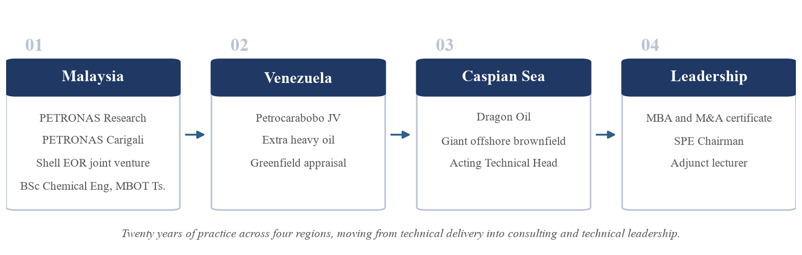
Figure 1: Career pathway of the speaker across four regions, as presented during the session
What this structure shows is an industry that is genuinely international in its staffing and its standards. An engineer trained in Malaysia can work on Venezuelan heavy oil or a Caspian offshore field because the underlying methods, the software and the reporting standards are shared across the sector. It also shows an industry that is heavily audited. Reserves figures are not simply declared by the operator, they are certified by independent third parties, which places a high value on technical work that can be defended under scrutiny.

1.3 Knowledge and experience gained
The most useful part of the session for me was the description of how a reservoir engineering problem is actually structured. The speaker set out a four stage sequence that moves from an ambiguous subsurface question to a set of options that can be presented for decision. This is shown in Figure 2.
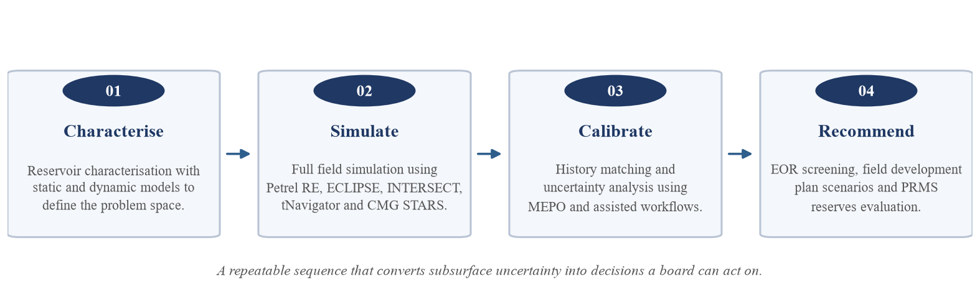
Figure 2: The four stage structured problem solving sequence described during the session
The first stage is characterisation, where static and dynamic models are built to define what is actually being dealt with. The second is simulation, where full field models are run in specialist software. The third is calibration, where the model is history matched against real production data and the remaining uncertainty is quantified. Only in the fourth stage does the engineer produce recommendations, such as enhanced oil recovery screening, field development plan scenarios and reserves evaluation under the Petroleum Resources Management System.
The third stage was the one I had least appreciation of beforehand. History matching means adjusting a model until it reproduces the production history that has already been observed, and only then using it to forecast. It is an admission that the first version of a model is very unlikely to be correct, and that the model has to earn trust against real data before anyone relies on its predictions. The software used at each stage is summarised in Table 2.
Table 2: Reservoir engineering software described during the session and its purpose
Tool | Purpose in the workflow
Petrel RE | Static and dynamic reservoir modelling and visualisation
ECLIPSE and INTERSECT | Full field reservoir simulation and production forecasting
tNavigator | High performance simulation and assisted history matching
CMG STARS | Thermal and advanced enhanced oil recovery process modelling
MEPO | Assisted history matching and uncertainty analysis
OFM, MBAL and PROSPER | Production surveillance, material balance and well performance
The speaker also made the point that technical work is only valued when it can be expressed as a business outcome. He presented the results of his projects in commercial terms rather than in modelling terms, and these are summarised in Figure 3. Reserves additions, production growth, recovery factor improvement and arrested decline were the measures he used, along with cost savings from modernising simulation workflows and from fixed term surveillance contracts.
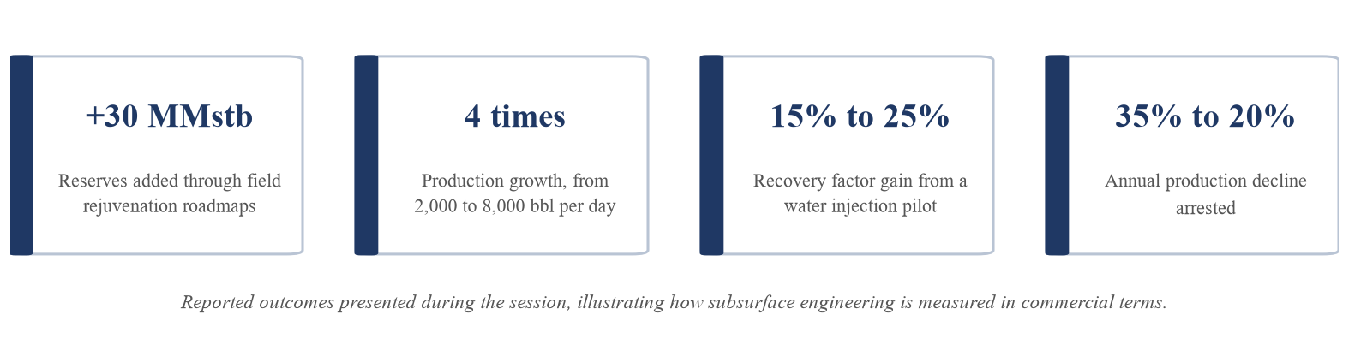
Figure 3: Business outcomes presented during the session
A further part of the session dealt with stakeholder management, which he treated as a technical skill rather than a soft one. He described four distinct groups. Partners such as SLB required joint working on shared models. Auditors such as Ryder Scott and Gaffney Cline required technical work to be defended in detail during reserves certification. Regulators and host governments required peer review and approval across different jurisdictions. Local teams required mentoring and capability building so that the work could continue after a consultant left. His Baronia full field review was presented as an example where all four had to be satisfied within a single deliverable.

1.4 Reflection on independent learning
Almost none of the technical content of this session appears in the mechatronics curriculum. Reservoir characterisation, history matching, enhanced oil recovery screening and reserves classification under an international standard are not subjects I have studied, and the software involved is specific to the petroleum industry. The value of the session for me was therefore not that I can now perform this work, because I clearly cannot. It was that I could see the shape of a discipline I had no exposure to and recognise which parts of it transfer.
Two things transfer directly. The first is the discipline of calibrating a model against reality before trusting it. In my own placement I built a large automation pipeline and my instinct was to build quickly and correct problems as they appeared. The history matching stage is the same idea applied properly and in advance, where the model is deliberately tested against known data before any forecast is made. The second is the habit of presenting work as a recommendation rather than as a result. The speaker was direct about this and listed it as one of his key lessons for anyone entering consulting. Boards want a clear option set, not a description of the analysis.
The session also changed how I think about the commercial side of engineering. His advice to combine engineering with commercial understanding, supported by an MBA and merger and acquisition training, described a career path where technical depth is the entry requirement rather than the destination. This connects to work I did during my own placement on a market entry strategy, where the technical proposal only became useful once it was costed and phased. Seeing a senior engineer describe the same pattern after twenty years gave me more confidence that this was a genuine feature of engineering practice rather than something specific to my placement.
Finally, his advice to keep learning across geographies and asset types is a direct statement about life-long learning. He moved from Malaysian fields to Venezuelan heavy oil to a Caspian brownfield, and each move required learning a different reservoir type and a different regulatory environment. That is independent learning driven by the demands of the work rather than by a syllabus, and it is the same pattern I recognise from teaching myself geospatial tools during my placement.

1.5 Critical evaluation of the session
The session was persuasive, but several points are worth questioning rather than accepting as presented.
The first concerns the business impact figures. Production growth from 2,000 to 8,000 barrels per day is presented as an outcome of the work, but no baseline was given for what the field would have produced without the intervention. In a technical report that comparison would be expected. This is not a criticism of the engineering itself, and the speaker was addressing students rather than auditors, but it is a reminder that industry presentations are built to persuade and should be read with the same care as any other source.
The second concerns his advice to speak in recommendations. The reasoning is sound, since a board cannot act on an undigested set of scenarios. The risk is that compressing a probabilistic forecast into one clear recommendation can remove exactly the uncertainty the decision depends on. He partly answered this himself by treating uncertainty analysis as a formal stage of the workflow, but the tension between being clear and being honest about what is not known was not fully resolved.
The third is that the session was much stronger on what worked than on what did not. Twenty years of reservoir modelling must include forecasts that turned out to be wrong, and hearing one of those in detail would have been more instructive than another success case. Models that fail usually teach more about the limits of a method than models that succeed.

1.6 Personal takeaway
The point that stayed with me came out during the question and answer session, when I asked how he deals with a history matched model that still turns out to be wrong. His answer was that a history match is not proof that a model is correct, only that it is not obviously wrong, because several different combinations of parameters can reproduce the same production history. He said the more useful question is not whether the model is right, but whether the decision would change if it were wrong.
That reframing was the most valuable thing I took from the session. I had been treating a validated model as an answer. He treats it as a way of testing how sensitive a decision is to being wrong, which is a more defensive and more honest way to work.
It also connects directly to my weakest Programme Outcome. Problem analysis is not only about decomposing a problem correctly at the start, it is about understanding it well enough to know which errors would actually matter. That is a more precise definition of the gap than the one I had before the session.

2. Nafem Report

2.1 Overview of the session
The second session was delivered by Ir. Ts. Mohd Nurul Amin bin Adnan at the Asia Pacific University of Technology and Innovation on 28 July 2026, under the title “Finite Element Analysis: Beyond Colorful Contours”. The speaker is a registered Professional Engineer with the Board of Engineers Malaysia and a registered Professional Technologist with the Malaysia Board of Technologists, and has about sixteen years of experience in simulation across several industries. The title of the talk carried its main argument. A finite element result is easy to produce and easy to present as an attractive contour plot, but the plot itself proves nothing about whether the analysis is correct. Table 3 summarises the session.
Table 3: Details of the NAFEMS and finite element analysis session
Item | Detail
Title | Finite Element Analysis: Beyond Colorful Contours
Speaker | Ir. Ts. Mohd Nurul Amin bin Adnan, P.Eng (BEM), P.Tech (MBOT)
Date | 28 July 2026
Venue | Asia Pacific University of Technology and Innovation, Kuala Lumpur
Experience | Sixteen years in automotive, aerospace, transportation, renewable energy, oil and gas and power generation
Current role | Simulation Manager, ORS Technologies Sdn. Bhd.
His career illustrates how widely simulation is applied. He began as a computer aided engineering engineer at PROTON working on the Preve, Suprima and Iriz vehicle programmes, then moved to STRAND Aerospace where he carried out stress checks on the wing hydraulics of the Airbus A350-XWB.
He later worked at SCOMI Group on the Kuala Lumpur and Mumbai monorail projects and on a thirty megawatt solar farm, then on valve design for oil and gas at MIR Valve, structural skid design for Tenaga Nasional Berhad generation projects at ESRA, and advanced diagnostics and prognostics within PETRONAS Group Technical Solutions. The same underlying method supported work in six different industries, which is a strong argument for treating simulation competency as a transferable professional skill rather than a company specific one.

2.2 Finite element analysis and computer aided engineering in practice
Finite element analysis is a numerical method for solving problems in engineering and mathematical physics. It is used where the geometry, the loading or the material behaviour is too complicated for a closed form analytical solution to be obtained. Computer aided engineering is the broader use of software to simulate performance, improve designs and support the validation and optimisation of products and manufacturing processes. The speaker made the point that the distinction between the two terms is largely a matter of industry convention. The automotive sector tends to say computer aided engineering, while the oil and gas and aerospace sectors tend to say finite element analysis. In practice both describe the same activity of using software to solve complex equations that represent a physical problem.
He also explained that a modern simulation workflow is usually assembled from several different software packages rather than a single product, and that these now integrate with one another. This is summarised in Table 4.
Table 4: Typical simulation toolchain by stage, as described during the session
Stage | Examples given | Function
Pre-processing | ANSA, HyperMesh, PATRAN | Geometry preparation and mesh generation
Solving | ANSYS, NASTRAN, RADIOSS, HyperWorks, ABAQUS | Numerical solution of the governing equations
Post-processing | HyperView, ANSYS Workbench | Interpretation and presentation of results
His view on software choice was deliberately blunt. He argued that no commercial package is inherently better than another, that the practical differences lie in the user interface and in what an organisation can afford, and that the software is only a tool. In his words, what matters is not which tool is used but who is using it, and the best software is the one already available. For a student this is a useful correction, because it moves the question away from which package to put on a curriculum vitae and towards whether the underlying engineering is understood.

2.3 Why simulation competency needs independent verification
The strongest part of the session was the discussion of accuracy, and it is the part that explains why a body such as NAFEMS exists at all. The speaker was clear that simulation cannot replace physical testing. Results typically deviate from a physical test by up to thirty per cent, and agreement within five per cent is regarded as a very good outcome. Accuracy depends on the quality of the geometry model, the quality of the mesh elements, the setup of the boundary conditions and the accuracy of the material property data. He summarised the consequence with the phrase “rubbish in, rubbish out”. If the model is set up incorrectly then the results are wrong, regardless of how convincing the output looks. This relationship is shown in Figure 4.
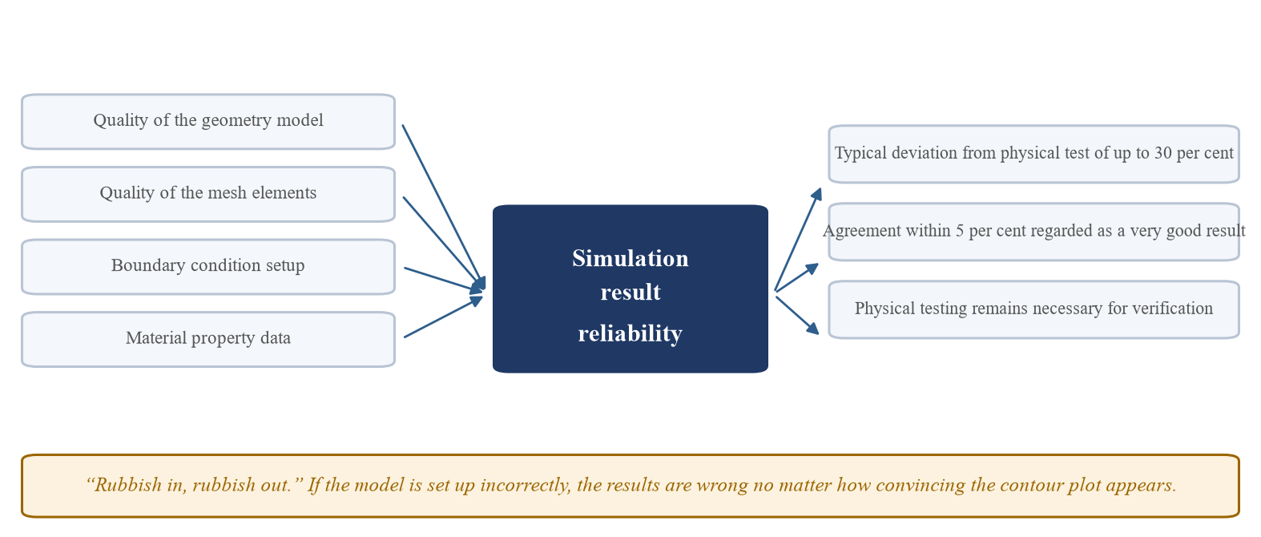
Figure 4: Factors governing simulation reliability and the limits of accuracy discussed in the session
This creates a problem that is different from most other engineering tools. A wrongly set up simulation does not fail visibly. It produces a smooth, colourful and entirely plausible result that can be placed in a report and used to justify a design. The error is invisible to anyone who does not understand how the model was built, including the manager or client receiving the result. Where that design is a pressure vessel, a monorail structure or an aircraft wing component, the consequences of an undetected modelling error are severe.
This is why simulation competency is a professional and ethical issue and not only a technical one. The Board of Engineers Malaysia code of professional conduct requires an engineer to act only within their area of competence and to be honest about the limits of their work. An engineer who presents a simulation result without understanding its assumptions is in breach of that principle even if nobody ever discovers the error.
The difficulty is that competency in simulation is hard for an employer to verify, because the work is specialised and the output always looks finished. Independent certification is a direct response to that difficulty.

2.4 NAFEMS as an international professional body
NAFEMS was established in 1983 and was originally known as the National Agency for Finite Element Methods and Standards. It now describes itself as the international association for the engineering modelling, analysis and simulation community. It is an independent not-for-profit association, which matters because it means it is not owned by or aligned with any software vendor. Its guidance can therefore address good practice in simulation generally rather than promoting a particular product. Its activities cover finite element analysis, computational fluid dynamics and multiphysics simulation, and include training, certification, conferences and technical publications.
The organisation is governed through a world council based in the United Kingdom, supported by regional groups and by technical working groups that each cover a specialist area. Its membership includes organisations such as NASA, Airbus, Rolls-Royce, Boeing, Nokia and the University of Nottingham, which indicates that the standards it develops are shaped by organisations operating at the highest level of safety criticality. The structure is shown in Figure 5.
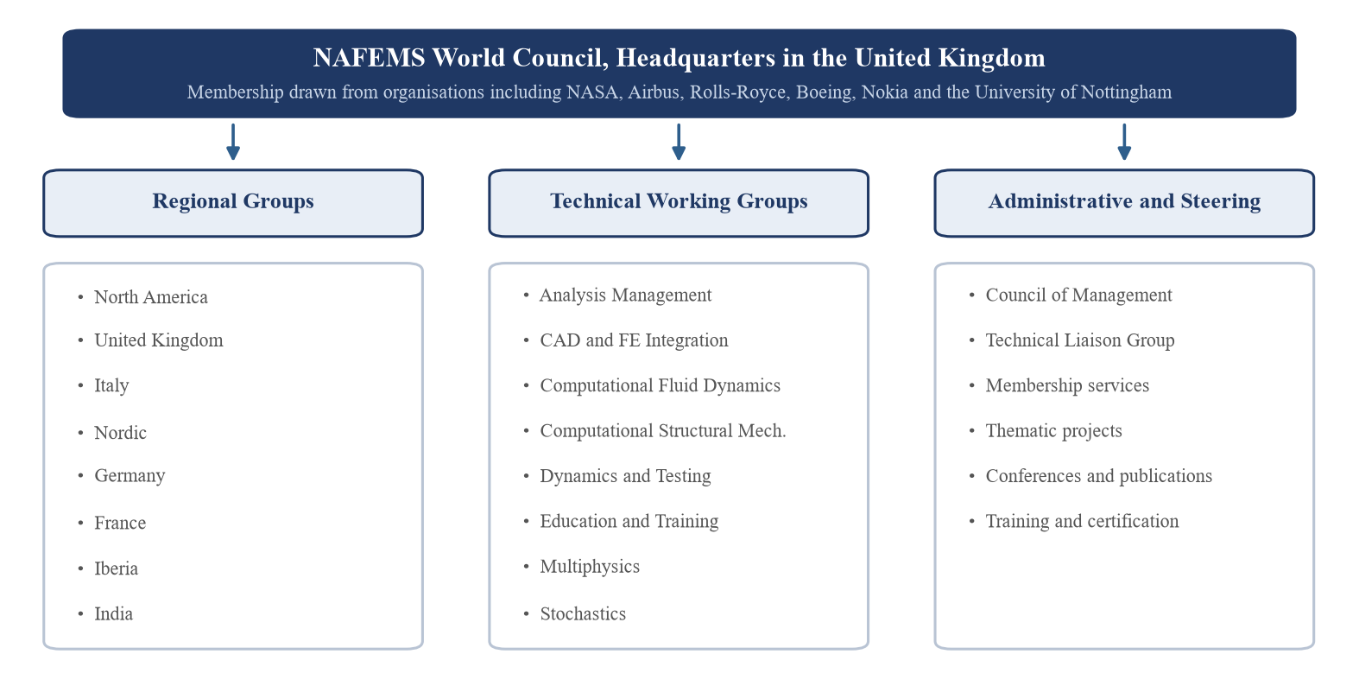
Figure 5: Organisational structure of NAFEMS, compiled from NAFEMS reference material
The technical working groups are worth noting individually, because they show what the simulation community currently considers important. Alongside established areas such as computational fluid dynamics and computational structural mechanics, there are groups for analysis management, for the integration of computer aided design with finite element models, for dynamics and testing, for education and training, for multiphysics and for stochastics. The presence of a stochastics group is significant, since it reflects a shift away from single deterministic answers and towards analysis that treats uncertainty explicitly. That is the same idea I encountered in the reservoir session through uncertainty analysis and history matching.

2.5 The Professional Simulation Engineer certification
The Professional Simulation Engineer certification, usually shortened to PSE, is the NAFEMS scheme for recognising individual competency in simulation. According to NAFEMS reference material, it was developed in response to a need expressed by the community for independent verification of workplace competency. The competencies themselves were peer reviewed over several years by the technical working groups and by external experts, and incorporate thousands of statements of competency defined at different levels. The route to certification runs through NAFEMS recognised training courses combined with assessment, leading to entry level certification and then to progression through higher levels and specialist domains. This is shown in Figure 6.
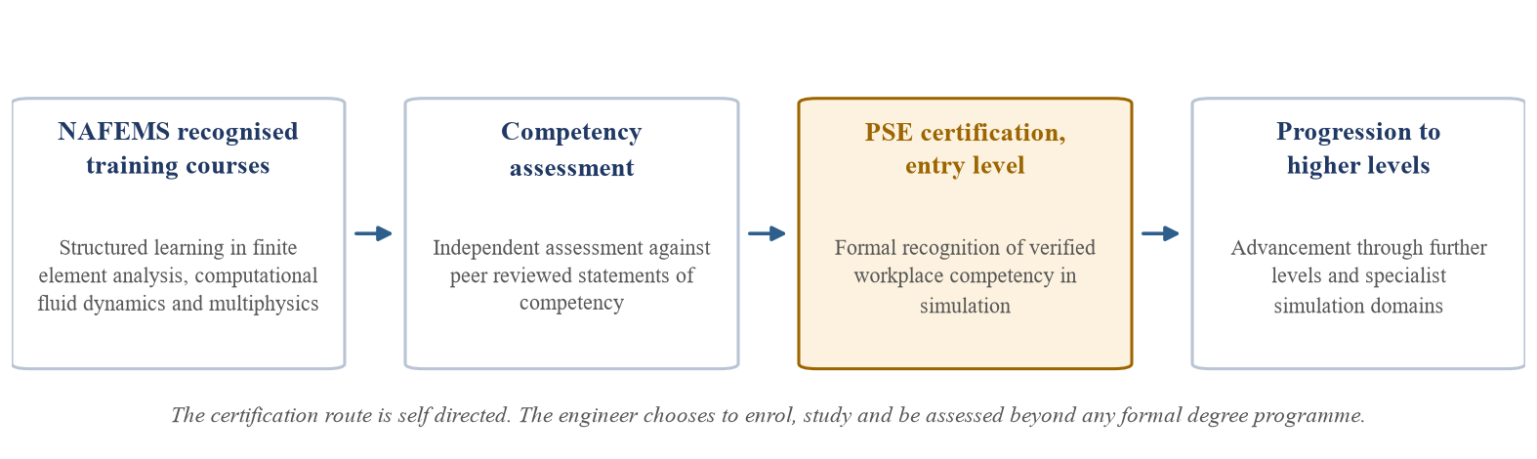
Figure 6: Route to Professional Simulation Engineer certification
Two features of this scheme are worth drawing out. The first is that the assessment is independent of the employer, so the certification records what the individual can actually do rather than what a particular company is willing to state about them. The second is that competency is defined at levels and by domain, which acknowledges that simulation is not a single skill. An engineer competent in linear static structural analysis is not automatically competent in computational fluid dynamics or in non-linear dynamics. Table 5 sets out the benefits of the scheme as described in NAFEMS material.
Table 5: Reported benefits of PSE certification for individuals and for organisations
For the individual engineer | For the employing organisation
An internationally recognised qualification that is distinct from any single employer | A clear demonstration of the organisation's commitment to quality standards
A defined path for career and skill progression | A formal record of employee competency and training that supports ISO 9001 requirements
Increased value to current and future employers | Easier recruitment of high calibre analysis staff
Improved analytical skills and greater confidence in the work produced | Reduced risk when engaging consultants and subcontractors who hold the certification
Improved self-motivation towards continued development | Increased staff motivation and a competitive advantage in tendering
The link to ISO 9001 is the part I found most revealing. It shows that individual competency certification is not only a personal achievement but also a quality management requirement for the organisation. A company that cannot evidence the competency of the people producing its analysis has a gap in its quality system. This reframes life-long learning as something an employer has a direct interest in supporting rather than something an engineer pursues privately.

2.6 Independent and life-long learning through certification
Participation in a scheme such as PSE reflects a commitment to professional development for a simple reason. It is entirely voluntary. No degree programme requires it, no employer can complete it on an engineer's behalf, and the courses and assessments have to be pursued on the engineer's own initiative and usually in their own time. Choosing to be assessed against an external standard also carries the risk of being found not yet competent, which is a different proposition from attending a course and receiving a certificate of attendance. That willingness to be measured is what separates genuine professional development from the accumulation of credentials.
The structure of the scheme also reflects the nature of engineering knowledge. Because certification is offered at several levels and across several domains, it is designed to be returned to rather than completed once. An engineer who certifies in structural analysis and later moves into thermal or fluid work has to develop and demonstrate competency again. This matches how a career actually develops, and it makes clear that formal education is a starting point rather than a qualification for a whole working life. The speaker's own career, moving from automotive to aerospace to rail to oil and gas, is an example of exactly this pattern of repeated re-learning.

2.7 Adaptability to new and emerging technologies
Simulation is changing quickly, and several of these changes were visible in both sessions. Digital twins connect a simulation model to live sensor data from a physical asset so that the model is continuously updated. Machine learning is being used to produce surrogate models that approximate expensive simulations and allow far more design variants to be explored. Cloud and high performance computing have removed much of the hardware constraint that previously limited model size. Simulation features are also being embedded directly into computer aided design software, which places analysis tools in the hands of designers who are not analysis specialists.
The last of these developments creates a paradox that I think is the strongest argument for certification. As simulation tools become easier to use, the barrier to producing a result falls, but the barrier to producing a correct result does not fall at all. The factors the speaker identified, namely mesh quality, boundary conditions and material data, still determine whether the answer is meaningful. A tool that hides those decisions behind default settings makes it easier to generate a confident and wrong answer. Wider access to simulation therefore increases rather than decreases the need for a recognised way of demonstrating that the person running the analysis understands what the software is doing.
The same reasoning applies to artificial intelligence in simulation. A surrogate model trained on simulation output inherits every weakness of the data it was trained on, so the principle of rubbish in and rubbish out applies with more force rather than less. Judging whether a machine learning prediction is physically reasonable requires the engineering understanding that certification is intended to verify. The reservoir session gave a practical example of this in the artificial intelligence based sweet spot evaluation used to identify drainage points, where the output still had to be defended to auditors and regulators by an engineer who understood the underlying reservoir behaviour.

2.8 NAFEMS alongside the Malaysian professional routes
The speaker also set out the professional registration routes available in Malaysia, and it is useful to see where an international certification such as PSE fits alongside them. Registration as a Graduate Engineer with the Board of Engineers Malaysia, or as a Graduate Technologist with the Malaysia Board of Technologists, is the first step on graduation. Progression to Professional Engineer can then follow one of three routes, namely passing the Board of Engineers Malaysia professional assessment examination, completing a code of conduct assessment where the engineer is already certified by an overseas regulatory body, or holding corporate membership of the Institution of Engineers Malaysia. Progression to Professional Technologist follows the parallel technologist route. Figure 7 compares these with the NAFEMS scheme.
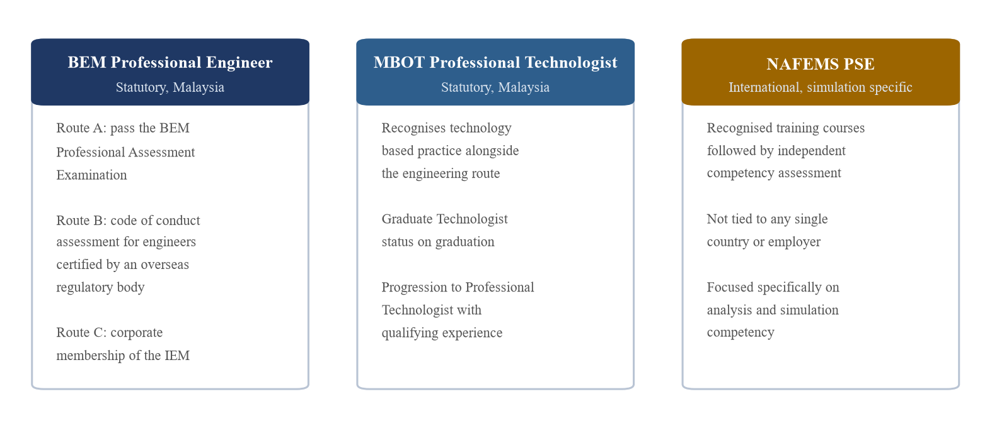
Figure 7: Comparison of Malaysian statutory registration routes with the NAFEMS certification scheme
The two types of credential do different work and are not alternatives. The Malaysian registrations are statutory and jurisdictional. They establish the legal right to practise and to take responsibility for engineering work within Malaysia, and they cover professional conduct across engineering as a whole. The NAFEMS certification is not statutory and confers no legal standing, but it is specific and international. It states what an engineer can competently do within simulation, and it means the same thing to an employer in Malaysia, the United Kingdom or the United States. An engineer intending to specialise in simulation would sensibly pursue both, using the statutory route to establish professional standing and the NAFEMS route to evidence technical depth in a specialism that a general registration cannot describe.

2.9 Personal position and plan
I should be straightforward about my current position. I have not registered for NAFEMS membership or begun any of the recognised courses, so this section reflects recognition of the need for that development rather than a record of having completed it. What the session changed was my understanding of why such a scheme exists, which I would not have appreciated before. My previous view of simulation was that it was a matter of learning a software package. The argument that results routinely deviate by up to thirty per cent, and that competency rather than software choice is the limiting factor, replaced that view with something more realistic.
Simulation is also more relevant to my own field than I had assumed. The speaker noted that although finite element analysis is usually associated with mechanical and civil engineering, it is applied in electrical and electronic engineering, chemical process engineering, biomedical engineering, sports science and motorsport. For a mechatronics engineer working across mechanical and electronic domains, this is directly applicable. My final year project involves a solar powered mobile water purification system, which has structural, thermal and fluid aspects that could all be analysed rather than only tested, and the theft deterrent battery enclosure I worked on during my industrial placement was validated by printing and physically testing prototypes when a structural analysis could have narrowed the design space first.
My plan follows the sequence the speaker recommended. The first priority is the fundamentals, because he was explicit that understanding statics, dynamics, solid mechanics, heat transfer and fluid mechanics matters more than any particular software. The second is to register as a Graduate Engineer with the Board of Engineers Malaysia and as a Graduate Technologist with the Malaysia Board of Technologists on graduation, since these establish professional standing from the start.
The third is to use the free technical publications and webinars that NAFEMS makes available in order to build familiarity before committing to a recognised course, and then to pursue entry level certification once I am working in a role where simulation forms part of my responsibilities. Pursuing certification without applying it in real work would produce a credential without competency, which is the outcome the scheme exists to prevent.

2.10 Critical evaluation
Two arguments made during the session deserve to be challenged, and the certification itself has limitations that were not discussed.
The claim that no simulation software is better than any other is too strong as stated. It is true that competency matters more than brand, and that most commercial packages will solve a standard linear static problem equally well. It is not true that the choice reduces to user interface and budget. Solvers differ materially in how they handle explicit dynamics, contact and highly non-linear material behaviour, and selecting the wrong one for a given physics problem is itself a competency failure. The weaker version of his argument is correct and useful. The stronger version would not survive contact with a specialist application.
The certification also has practical limits. NAFEMS recognised courses are paid, so access depends on either personal funds or an employer willing to sponsor them. That risks turning the credential into a marker of who works for a well resourced organisation rather than who is genuinely competent, which is close to the opposite of what an independent assessment is meant to achieve.
The scheme is also not statutory. Unlike registration with the Board of Engineers Malaysia, it carries no legal standing, so its value depends entirely on whether employers choose to recognise it. In a market where few employers ask for it, an engineer could hold the certification and gain very little from it.
There is a further tension in how the competencies are maintained. Their credibility comes from being peer reviewed over several years by the technical working groups, which is exactly what makes them rigorous. That same review cycle makes it hard to keep pace with areas moving quickly, such as machine learning surrogate models. A framework that takes years to agree will always lag a technique that changes annually. None of this removes the case for certification, but it does suggest the certification should be treated as evidence of competency rather than proof of it.

2.11 Personal takeaway
The sentence that stayed with me was that the most important variable is not which tool is used but who is using it. During the question and answer session I asked how a graduate is supposed to build that credibility when they are not yet able to judge whether their own results are correct.
His answer was that you never validate your own work in isolation. Early in a career the correct approach is to check every result against something independent, whether a hand calculation, a simplified analytical case with a known solution, or a physical test. He said the engineers he worries about are not the ones who make mistakes, but the ones who have no second method to catch them.
That changed how I think about my own competence. I had assumed becoming a good analyst meant reaching a point where I could trust my own output. He described almost the opposite, where the mark of a competent engineer is the habit of not trusting it and always holding an independent way to check. The certification then makes sense as a formal record of a habit that has to exist first, rather than as a substitute for it.
This applies directly to my final year project. I have been validating the water purification system by building and testing it, which is slow and only ever tests the one configuration I happened to build. A simple thermal or hydraulic calculation beforehand would have narrowed the design space and, more importantly, would have given me a second independent check on the physical result instead of treating the prototype as the only source of truth.

3. E-Portfolio Report
This section reflects on my attainment of the Programme Outcomes across my degree, drawing on my academic record, my industrial placement and the two industry sessions discussed above.

3.1 Self-Introduction
My name is Tegar Wicaksono and I am an aspiring Mechatronics Engineer completing my BEng (Hons) in Mechatronics Engineering at the Asia Pacific University of Technology and Innovation. Mechatronics combines mechanical systems, electronics, control theory and software. This mix of disciplines has shaped how I approach engineering, because it has trained me to look at a problem from several technical angles rather than only one. Throughout my degree I have worked to build a consistent standard of professionalism, which in practice means producing well documented technical work, communicating clearly with supervisors and peers, and taking responsibility for meeting deadlines and quality standards.
These values were tested during my four month industrial placement as a Future Technology and Network Engineer Intern at EDOTCO Group Malaysia, from 23 June to 24 October 2025. EDOTCO is Asia's first regional integrated telecommunications infrastructure company. I was rotated across the Engineering division, working with the Energy team, the Network Performance and Future Technologies team, and Field Operations. This gave me a view of the full telecommunications tower lifecycle rather than a single narrow task, and it showed me how strategy, mechanical research and development, geospatial analysis and field maintenance connect to one another.
My placement began with strategic research. I studied EDOTCO's corporate objectives and then developed site security and theft deterrence concepts together with a market entry strategy for the company's Indonesia National Telecommunications Centre. This required me to coordinate directly with Indonesian colleagues to understand their operational and regulatory context before producing a phased rollout proposal, and it was an early lesson that engineering decisions cannot be separated from commercial and cultural realities. I then joined the Energy team's Project Lockdown, a research and development initiative to redesign the site battery compartment to deter equipment theft, where I modelled prototype components in Autodesk Fusion 360 and 3D printed parts to test their fit and assembly across several rounds of functional testing.
In the second half of the placement I moved into Network Performance and Future Technologies. There I taught myself a geospatial toolchain including Google Earth Pro, CARTO Builder and QGIS, together with Python and its geospatial libraries such as GeoPandas and Shapely. I used these to map national parks and forest reserves across Sri Lanka for environmental compliance planning, to clean and analyse raw footfall datasets, and to produce heatmaps showing high traffic zones for network planning. I also compared footfall data from several external providers to assess its reliability and bias, and carried out a functionality and bug audit of EDOTCO's internal Network Analysis platform.
The most demanding task of the placement was designing and running a Python automation pipeline that produced roughly 17,000 pages of individual site information reports. This required resilient code capable of handling large and inconsistent datasets, a period of working from home during which I monitored the job and corrected data errors as they appeared, and a written user guide so that staff could maintain the tool after I left.
Alongside this I contributed to EDOTCO's internal innovation competition, where I helped propose and technically scope an artificial intelligence based site security system for theft reduction.
A recurring theme across the placement was practising professionalism outside a conventional office. Coordinating the Indonesia strategy meant working with a team I had never met, across a language and cultural gap, and earning their trust before any technical work could begin. Monitoring the automation run from home required a different kind of professionalism, because no supervisor was present and accountability had to be self imposed. Between these two experiences I came to treat professionalism as a consistent standard I hold regardless of who is watching or where I am working.
The two industry sessions covered in this report extended that view. Ts. Izwan Adnan showed how technical depth becomes valuable only when it is expressed as a decision, and Ir. Ts. Mohd Nurul Amin showed that competency with a tool is a professional obligation rather than a personal preference. Both reinforced my intention to keep learning deliberately after graduation as I move towards a career in network automation and smart infrastructure engineering.
I have also published an online version of this portfolio, which presents the same material in an interactive format intended for prospective employers. It is available at [insert portfolio website link here]. Building and maintaining the site was itself an exercise in self directed learning, since it required me to work with web technologies that fall outside the mechatronics curriculum.

3.2 SWOT Analysis
The analysis below examines my Programme Outcome attainment with a focus on professionalism, decision making, independent learning and engagement with new technology. It draws on two sources of evidence, namely my official APU School of Engineering PLO Report Card for Year 4 Semester 1 and my industrial placement at EDOTCO Group Malaysia. Each point is linked to a specific Programme Outcome so that the reflection rests on evidence rather than opinion.
Table 6: SWOT summary of Programme Outcome attainment and placement experience
- Full attainment at 100 per cent in 11 of 12 Programme Outcomes.  - PLO5, design of innovative solutions, evidenced by Project Lockdown from CAD concept to a tested 3D printed part.  - PLO3, selection and use of suitable tools, through self taught QGIS, CARTO, GeoPandas and Shapely.  - PLO11 and PLO9, evidenced by the 17,000 page automation task delivered under unsupervised conditions.  - PLO6 and PLO10, through cross border and cross department collaboration.  - PLO12, through the market entry strategy and innovation competition cost scoping. | - PLO2, complex problem analysis, at 83.3 per cent and the only outcome below full attainment.  - The automation pipeline was not fully planned at the start, so data errors appeared during the run and were corrected reactively.  - Breadth across many teams has limited deep specialisation in any single area.  - Design work still tends to be refined by iteration rather than specified fully before building.
  STRENGTHS
  WEAKNESSES
- Growing overlap between mechatronics, telecommunications infrastructure, IoT and geospatial analytics.  - Formal certification in GIS, Python data analysis or simulation would give recognised proof of self taught skills.  - Professional registration with BEM and MBOT on graduation, and NAFEMS certification later.  - Innovation programmes offer practice with open ended problems, which targets the PLO2 gap directly.  - A possible graduate pathway at EDOTCO or a comparable regional infrastructure company. | - Automation and simulation tools change quickly, so specific platform skills can become outdated.  - Graduates increasingly combine software skills with core engineering, which raises the competitive bar.  - Over reliance on particular platforms could weaken my grasp of underlying engineering principles.  - Cost, land use and regulatory limits can restrict how far ambitious engineering proposals are funded.
  OPPORTUNITIES
  THREATS

3.2.1 Strengths
My clearest strength is a consistent record of Programme Outcome attainment. I achieved full attainment at 100 per cent in 11 of my 12 Programme Outcomes, including design, communication, sustainability, professional conduct, teamwork, life-long learning and economic decision making. Taken together these describe a balanced profile rather than a narrow technical one.
The second strength is the ability to carry a design through to something physical. Project Lockdown required me to move from a concept in Fusion 360 to a 3D printed component that was tested for fit and assembly and then revised. This corresponds to PLO5 and shows that I can take a solution from theory into a working artefact rather than stopping at the drawing.
The third is delivery at a scale beyond coursework. Designing and running the pipeline behind 17,000 pages of site reports, including unsupervised monitoring and correction of data errors while the job was running, demonstrates ownership and persistence. This supports PLO11 and PLO9 in particular, because the work depended on self direction and on holding my own standards without supervision.
The fourth is applied and self taught tooling. QGIS, CARTO, Google Earth Pro and the Python geospatial libraries were all learned on the job and are well beyond the standard mechatronics curriculum, which supports PLO3. The fifth is professional communication across borders and departments, supporting PLO6 and PLO10, since coordinating with Indonesian colleagues required me to explain technical detail to an audience whose primary concern was commercial and operational. The sixth is commercial judgement under PLO12, since both the market entry proposal and the innovation competition submission required me to weigh cost, infrastructure compatibility and organisational feasibility rather than technical merit alone.

3.2.2 Weaknesses
Problem analysis under PLO2 is my only outcome below full attainment, at 83.3 per cent. I take this seriously because my own experience supports it rather than contradicting it. My instinct on the automation project was to begin building quickly, and as a result several data errors were only discovered once the pipeline was already running and had to be corrected reactively rather than anticipated during a proper analysis stage.
Both industry sessions sharpened my understanding of this weakness. The reservoir workflow places characterisation and calibration before any forecast is produced, and the simulation session made clear that a poorly framed model produces a confident and wrong answer. In both disciplines the analysis stage is treated as the point where errors are prevented, whereas I have tended to treat it as preparation to be completed quickly before the real work starts. That is a specific and correctable habit rather than a general shortcoming.
My second weakness is breadth at the expense of depth. Rotating across strategic research, mechanical research and development, geospatial analysis, software quality assurance and automation built useful range, but it meant I rarely remained on one problem long enough to develop specialist mastery. Related to this, my design practice still relies on iteration to expose problems rather than on specifying a solution fully before building it.

3.2.3 Opportunities
The convergence of mechatronics with telecommunications infrastructure, IoT and geospatial analytics suits the combination of hardware and data experience I gained at EDOTCO, and it points towards network automation and smart infrastructure roles. Formal certification would convert several demonstrated but unaccredited skills into recognised qualifications, whether in geographic information systems, Python data analysis or, following the NAFEMS session, simulation competency.
Professional registration is a more immediate opportunity. Registering as a Graduate Engineer with the Board of Engineers Malaysia and as a Graduate Technologist with the Malaysia Board of Technologists on graduation establishes professional standing at the start of my career, and both speakers treated this as a routine first step rather than an optional one.
Continued involvement in innovation programmes would give me deliberate practice with open ended and poorly defined problems, which addresses my PLO2 gap directly. My placement performance may also open a graduate pathway at EDOTCO or a comparable regional infrastructure company.

3.2.4 Threats
The pace of change in automation, geospatial platforms and simulation tools means that specific technical skills can date quickly without continuous learning. The NAFEMS session made clear that this is a recognised problem across the profession rather than a personal one, and that structured certification is one response to it.
Graduates increasingly combine strong software skills with core engineering training, which raises the competitive bar for the roles I am targeting. Remaining competitive means maintaining both rather than specialising too early. There is also a risk in depending too heavily on particular platforms without an equally firm grasp of the underlying engineering and data principles, which is the same argument the simulation session made about software packages.
Finally, engineering work is constrained by cost, land use and regulation. I saw this during the Sri Lanka environmental compliance mapping, and both speakers described the same constraint in their own sectors. Limited budgets can restrict how far ambitious proposals are taken towards implementation, regardless of technical merit.

3.3 PO Attainment and Evaluation
This section evaluates my Programme Outcome attainment against the official APU School of Engineering framework. The twelve outcomes and their wording are taken from the School of Engineering PLO Guide, and each attainment figure is taken from my official PO Report Card for Year 4 Semester 1. Using the official wording rather than paraphrased outcome names ensures that each reflection maps to the outcome the programme actually measures.
Table 7: Programme Outcome attainment against the APU School of Engineering framework
PLO | Programme Outcome | Attainment
PLO1 | Apply principles of Mathematics, Science and Engineering to complex engineering problems | 100%
PLO2 | Undertake complex engineering problem analysis and apply engineering principles to solve them | 83.3%
PLO3 | Select and use suitable tools and techniques for complex engineering problems | 100%
PLO4 | Investigate complex engineering problems using research techniques | 100%
PLO5 | Design innovative solutions for complex engineering problems | 100%
PLO6 | Communicate effectively and professionally on complex engineering activities | 100%
PLO7 | Comprehend and demonstrate good practices of engineering in sustainable development and environmental considerations | 100%
PLO8 | Engage in professional engineering practice for safety, health, social, cultural and legal responsibilities | 100%
PLO9 | Execute the responsibilities of an engineer professionally and ethically | 100%
PLO10 | Function effectively as a team leader or member in multi-disciplinary settings | 100%
PLO11 | Recognise the need for, and engage in, independent and life-long learning for continuous professional development | 100%
PLO12 | Demonstrate entrepreneurship skills, engineering project management and economic decision-making | 100%
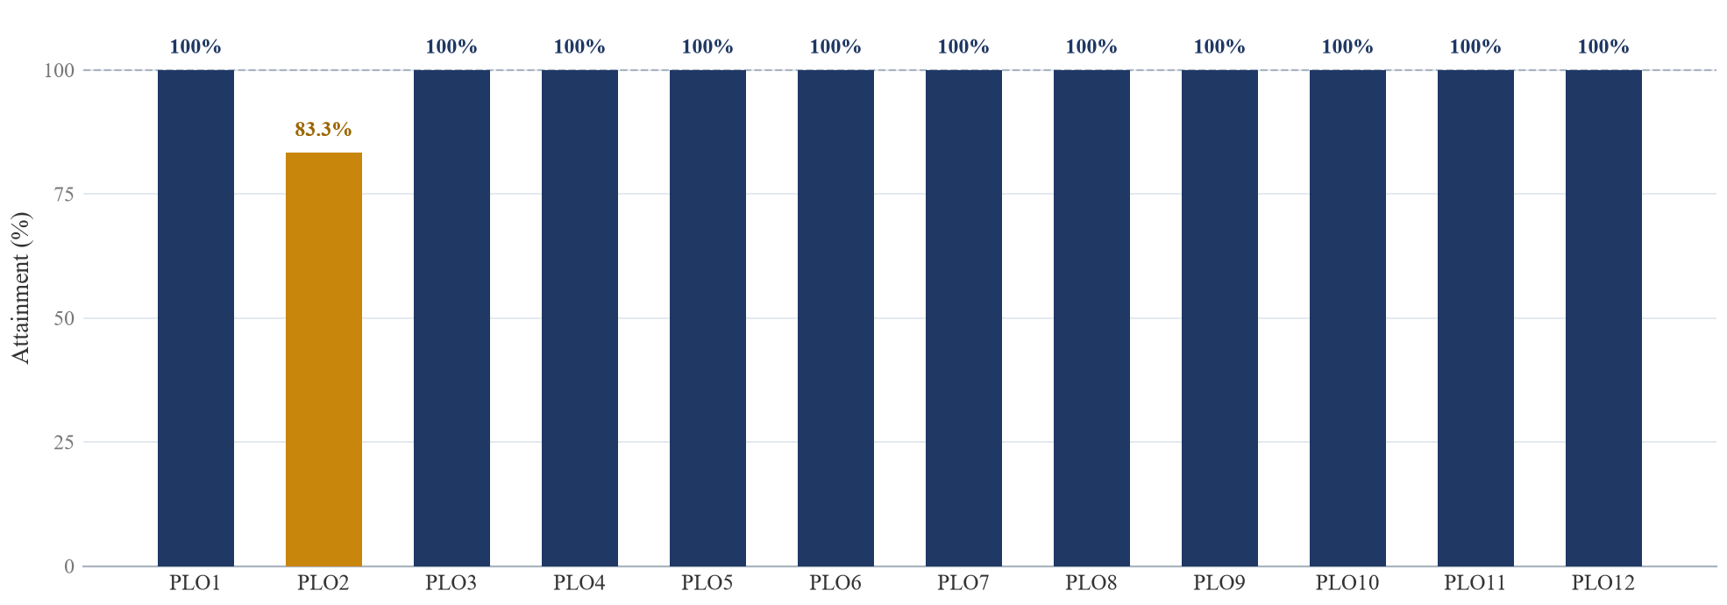
Figure 8: Programme Outcome attainment profile for Year 4 Semester 1

Professional conduct, ethics and inclusive practice
My attainment across the professionalism outcomes is supported by evidence from practice rather than by assertion alone. PLO9, which covers professional and ethical conduct, was demonstrated most clearly during unsupervised delivery of the automation run, where I maintained the same standards of documentation and honesty that I would have kept in an office. The same value appeared in the data work, where I flagged concerns about the reliability and bias of external footfall datasets rather than presenting more convenient figures. The simulation session gave me a sharper vocabulary for this. Presenting a result whose limitations you do not understand is a breach of professional conduct even when nobody discovers the error.
PLO8, covering safety, health, social, cultural and legal responsibilities, was engaged through the site security and theft deterrence work, which concerns asset protection, and through the Sri Lanka environmental compliance mapping, which is a legal and land use responsibility. PLO6 and PLO10 were exercised continuously as I moved between the Energy, Network Performance and Field Operations teams, and most visibly in coordination with Indonesian colleagues, where respecting language and cultural difference was a precondition for technical progress.

Independent and life-long learning with new technology
PLO11 is the outcome this portfolio is primarily assessed against, and it is where the evidence is strongest. Almost every technical capability I used at EDOTCO was acquired through self directed study rather than formal instruction. PLO3 follows from this, because I did not simply learn tools in the abstract but selected the appropriate one for each task, using QGIS and Google Earth Pro for spatial compliance mapping, CARTO for visualisation and Python for large scale automation. PLO5 is evidenced by Project Lockdown and by the innovation competition concept, where I moved from a problem to a new and tested solution.
The two sessions in this report added a dimension I had not previously considered, which is that independent learning has recognised structures attached to it. Before the NAFEMS session I understood life-long learning mainly as teaching myself whatever a project required. I now understand that professional bodies define competency explicitly, assess it independently and expect it to be maintained and extended over a career. That is a more demanding and more useful definition than the one I had been working with.

Sustainability, societal responsibility and economic judgement
PLO7 was addressed directly by mapping national parks and forest reserves across Sri Lanka so that network planning could avoid protected environments, which applied environmental and land use considerations to infrastructure decisions. PLO12 is the outcome my earlier self assessment recognised least. The Indonesia market entry strategy required a phased rollout plan that weighed commercial and operational risk, and the innovation competition submission required costing hardware and staffing so that an idea could become a funded project. The reservoir session reinforced this by presenting engineering results almost entirely in commercial terms, including reserves added, production growth and cost savings.

Performance gap and honest self-evaluation
The one clear gap is PLO2, complex problem analysis, at 83.3 per cent. My delivery and tool selection skills are strong, but the earlier discipline of decomposing an unclear problem is weaker. This means listing possible edge cases, defining what the data must look like and testing assumptions before writing code. Both sessions gave me concrete models for doing this properly, in the form of the characterise and calibrate stages of the reservoir workflow and the model setup discipline that determines whether a simulation is meaningful.

From evaluation to continuous improvement
These reflections lead to a specific plan. First, I will treat problem framing as a deliberate stage of every project by writing a short analysis and a list of edge cases before building anything, which converts my PLO2 gap into a strength. Second, I will register with the Board of Engineers Malaysia and the Malaysia Board of Technologists on graduation to establish professional standing early. Third, I will formalise my self taught geospatial and automation skills through recognised certification, and once I am working in a role where simulation is part of my responsibilities I will pursue NAFEMS entry level certification. Fourth, I will continue to seek open ended problems through innovation programmes and research related work, since these are the conditions that develop the outcome I am weakest in.

3.4 Conclusion
This report has allowed me to evaluate my attainment of the Programme Outcomes and my development as an aspiring Mechatronics Engineer, drawing on my official PLO Report Card, a varied industrial placement at EDOTCO Group Malaysia and two industry sessions delivered by practising engineers. Across strategic research, mechanical research and development, geospatial analysis, software quality assurance and large scale automation, I worked through most stages of the telecommunications infrastructure lifecycle, from concept and design through to field maintenance and data driven improvement.
Measured against the official APU School of Engineering framework, my record shows evidence based professionalism under PLO9, inclusive and legally aware practice under PLO8 and PLO10, effective cross cultural communication under PLO6, and a self directed commitment to new technology and life-long learning under PLO11, PLO3 and PLO5. Working from the official outcome wording also brought out strengths my earlier self assessment had overlooked, particularly entrepreneurship and economic decision making under PLO12 through the market entry strategy and the innovation competition submission. The record also gives an honest view of where I still need to develop, since problem analysis under PLO2 remains my clear priority.
The two sessions changed how I understand the outcome this portfolio is assessed against. Ts. Izwan Adnan showed that technical depth becomes valuable only when it is converted into a decision that a board or a regulator can act on, and that a career can be built by deliberately moving between geographies and asset types in order to keep learning. Ir. Ts. Mohd Nurul Amin showed that competency with a tool is a professional obligation, that a convincing looking result can be entirely wrong, and that professional bodies such as NAFEMS exist precisely because that competency needs independent verification. Both make the same underlying point from different directions, which is that formal education establishes a starting point and nothing more.
Three themes run through this report. Professionalism has come to mean holding a consistent standard whether I am in an office, coordinating remotely with an overseas team or working unsupervised from home. Independent learning has been driven by necessity as much as by interest, since the geospatial tools, the Python libraries and the automation methods were all learned because a real project required them, which gives me confidence that I can acquire whatever a future role demands. Finally, my direction for improvement is now specific. It is not about acquiring more tools, but about how I frame and analyse a problem before I begin building a solution.
I therefore move into the next stage of my career with confidence in my ethical grounding, my ability to work in diverse and distributed teams and my readiness to keep learning as technology changes, while remaining aware of the area where deliberate effort will make me a stronger engineer. My immediate goal is to enter the field as a network automation and smart infrastructure engineer, and to begin the professional registration and certification path that both speakers described as the foundation of a long engineering career.

References
Adnan, I. (2026) Lessons from a Reservoir Engineer. University sharing session, Asia Pacific University of Technology and Innovation, Kuala Lumpur, 30 July.
Adnan, M. N. A. (2026) Finite Element Analysis: Beyond Colorful Contours. Industry sharing session, Asia Pacific University of Technology and Innovation, Kuala Lumpur, 28 July.
Asia Pacific University of Technology and Innovation (2026) School of Engineering Programme Outcomes. Kuala Lumpur: APU.
Board of Engineers Malaysia (2026) Registration as a Professional Engineer. Available at: https://www.bem.org.my (Accessed: 30 July 2026).
Institution of Engineers Malaysia (2026) Corporate Membership. Available at: https://www.myiem.org.my (Accessed: 30 July 2026).
Malaysia Board of Technologists (2026) Professional Technologist Registration. Available at: https://www.mbot.org.my (Accessed: 30 July 2026).
NAFEMS (2026) About NAFEMS: the International Association for the Engineering Modelling, Analysis and Simulation Community. Available at: https://www.nafems.org (Accessed: 30 July 2026).
NAFEMS (2026) Professional Simulation Engineer (PSE) Certification. Available at: https://www.nafems.org/pse (Accessed: 30 July 2026).
Society of Petroleum Engineers (2018) Petroleum Resources Management System. Richardson, Texas: SPE.
Zienkiewicz, O. C., Taylor, R. L. and Zhu, J. Z. (2013) The Finite Element Method: Its Basis and Fundamentals. 7th edn. Oxford: Butterworth-Heinemann.

Appendix

Appendix A: Outline of the industry sharing session, 30 July 2026
- Career journey across four regions, covering Malaysia, Venezuela, the Caspian Sea and the move into consulting and technical leadership.
- Structured problem solving, presented as characterisation, simulation, calibration and recommendation.
- Stakeholder management across partners, reserves auditors, regulators and local teams.
- Business impact, presented as reserves additions, production growth, recovery factor improvement and cost savings.
- Technical toolkit covering reservoir simulation, characterisation and uncertainty, enhanced oil recovery and field development, and digital and artificial intelligence based surveillance.
- Key lessons for aspiring consultants, including converting technical depth into business value, speaking in recommendations, managing stakeholders, learning across geographies, combining engineering with commercial understanding and leading through mentoring.

Appendix B: Outline of the NAFEMS and finite element analysis session, 28 July 2026
- Introduction and speaker career history across automotive, aerospace, rail, valve manufacturing, energy and oil and gas.
- Definitions of finite element analysis and computer aided engineering, and the difference in terminology between industries.
- Simulation as a tool, including typical deviation from physical testing of up to thirty per cent and the factors governing accuracy.
- Software ecosystem across pre-processing, solving and post-processing, and the argument that competency matters more than software choice.
- Applications of simulation in product development and in fitness for service assessment of ageing equipment.
- Distinction between industrial, consumer and industrial consumer products and the standards applying to each.
- Career pathways, including graduate registration with the Board of Engineers Malaysia and the Malaysia Board of Technologists, the three routes to Professional Engineer status, and NAFEMS Professional Simulation Engineer certification.

Appendix C: Programme Outcome record
The Programme Outcome attainment figures used in Section 3 are taken from the official APU PO Report Card for Year 4 Semester 1, issued for programme APU4F2511. Eleven of the twelve Programme Outcomes are recorded at full attainment of 100 per cent, and PLO2 is recorded at 83.3 per cent.

Appendix D: Online portfolio
An online version of this portfolio is published at [insert portfolio website link here]. The site presents the placement work, the SWOT analysis, the Programme Outcome attainment record and the professional development pathway described in this report, in an interactive format aimed at prospective employers.

